|  |
| --- |
|  |
| 4.2 Computer System and software |
| Tutor Name: MS. Fatima Shemim |
|  |
|  |
|  |

|  |
| --- |
| Submitted by: Sadia Rasheed |

# Lo 1.1 Components of different computer system

Computer system: A computer system is a set of hardware and software. That is planned to process and manage to give the user a meaningful format. A computer attached with several units attached to it (mouse, Keyboard, speakers) is known as a computer system

# Different types of computer systems

## Personal computer

When we imagine a computer we portrait a personal computer. As its name represents that personal computer is used by an individual user at a time. According to size shapes, personal computers are divided into the following categories, here are some of them

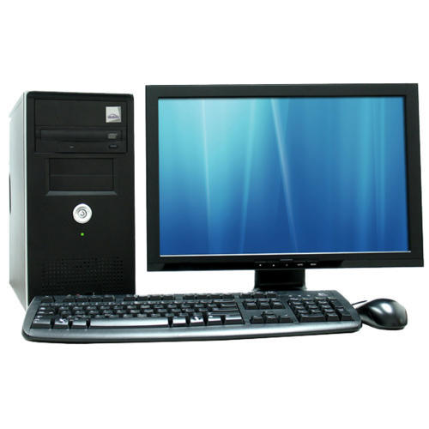Desktop computers: From its name we get to know that it’s placed on the desk it non-portable. Desktop computers have a system unit it controls all the working of the computer. All the peripheral devices (keyboard, monitor, and mouse) are connected to the system unit Figure 1 shows the desktop computer.

Figure 1.1 Desktop computer

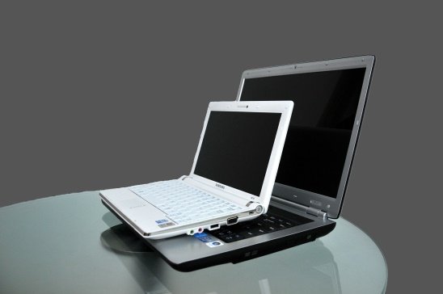

**Notebook Personal computer**: : Notebooks are single integrated personal use computers it is a portable device. it can be folded like a notebook for carrying it anywhere As shown in figure 1.2.The screen along with the keyboard and mouse is attached to it. these are also known as Laptops(lightweight analytical Platform total optimized power) The difference between laptops and notebooks is that notebooks are smaller in size as compared to laptops

Figure 1. notebook and laptop

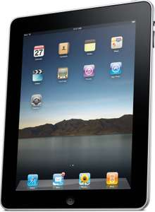**Tablet PCs :** A tablet is a touch screen portable device. There is no keyboard or mouse attached to with the help of our finger we can select, type move, drag and drop anything. There is no built-in software It is made up of plastic. It is lightly weighted we can carry it anywhere. Its size is intermediate between smartphones and notebooks

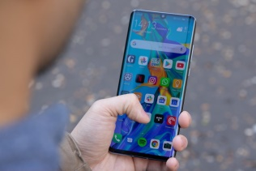

**Smart phones**: Smartphones are the combination of cellphones and touch-sensitive screens the same as tablet PCs. A smartphone has the same application as a computer and has access to the internet it provides features like calling, messaging, sending email, voice messaging and many other features. Smartphones have made our life easier.

### Multi- user computers

Multi-user computer systems are used in a large organization they are designed in a way that can be used by a group of people at the same time. Multi-user computers are classified into the following types

**Supercomputer**: Supercomputer is the largest the most expansive and powerful computers. Supercomputers were developed in the 1980s to handle difficult problems. The supercomputer uses a time-sharing mode in which thousands of users can connect with the computer at the same time. They are used in scientific space exploration, weather forecasting, aircraft design. Some examples of supercomputer CRAY -205, CRAY-1

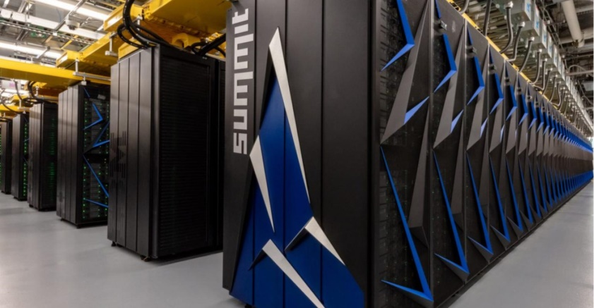

**Mainframe** Requires a large room. This type of computer system is powerful and has a very high speed. They are capable enough to hold a large amount of data and process mainframes are mostly used by governments, banks where thousands of users can do different jobs at the same time it surely means that the mainframe can do different jobs for different users at the same time. Early smaller and fewer fasters multi-users computers where known as minicomputers As compared to mainframe they were less expansive and now minicomputers are not in use. Figure 1.5 shows mainframe

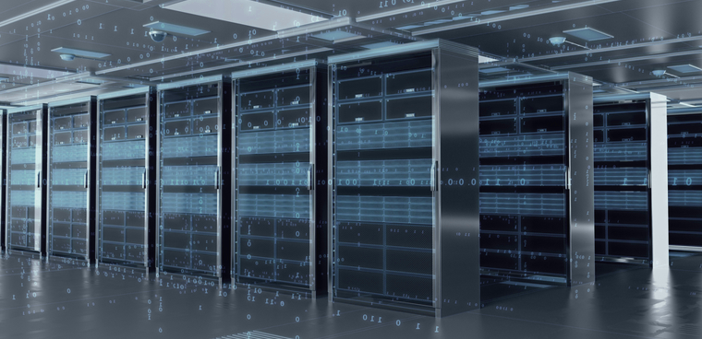

Figure 1.5 Mainframe

[https://www.google.com/search?](https://www.google.com/search?safe=strict&rlz=1C1SQJL_enAE834AE834&biw=1366&bih=657&tbm=isch&sxsrf=ACYBGNRJ1C4A9l9cjVwLPV4PBg6rx6mTsw%3A1572797116477&sa=1&ei=vPq-XfHQHMyFjLsPodi_iA4&q=mainframe&oq=main&gs_l=img.1.0.35i39l2j0i67l7j0.171876.174211..176067...1.0..4.263.2047.0j2j7......0....1..gws-wiz-img.....10..0i10i67j0i10j35i362i39.gEqX6cGIV9Q#imgrc=7JIVBI5LbVgbhM:)

A computer is divided in to two main divisions:-

* Computer Hardware
* Computer software

Computer Hardware basically mean the physical components of the system in other words the things which we can touch and which are essential for a computer to function is known as computer hardware. Everything is connected to the circuit board which operates within in the PCs and laptops. Which includes power supply, Computer case, Key board, monitor, mouse CPU (Central processing unit) it also includes all the part inside the CPU such as motherboard, graphic card, PORTS.

A computer system is divided in to three major parts:

* System units
* Input devices
* Output devices

The devices which are controlled by the CPU and which are attached with the system unit are known as Peripheral Devices. The most common devices are mouse keyboard printer speakers. Peripheral devices help the end user to communicate with system.

Four basic functions are performed by the computer system:

There are four important levels; four basic functions are performed by the computer to operate. **Input, output, Processing and storage. Input:** Gives or transfers information (through keyboard or mouse) **Output:** Displays that information which is given to it by an input device. (Through monitor). **Processing:** It process data / information and controls it **.Storage:** Stores that data for later use.

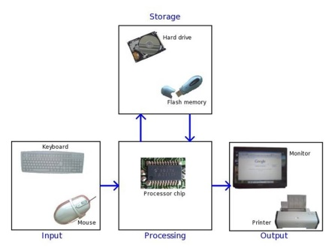

Figure 1.6 basic function of the computer system

Computer software: is a set of instruction that tells the computer what to do and how to do. Computer hardware are usless without computer software and similarly computer software is useless without computer hardware They should work together to obtain dersired result Computer software is further divided into Three categorious.

* System Software
* Application software
* Utility software

**System software:** System software controls and coordinates the computer and other application software. The following functions are performed by the system software: System

Software communicates with other peripheral devices and it supports in the execution, maintenance and development of other application software. System software is divided into three categories

* Operating system
* Programing language translator
* Service software

**Utility software:**

**A** utility software helps to maintain arrange and analyze computer. The software of utility program is smaller in size as compared to standard program. Utility software is installed with the operating system or we can install separately. Examples of utility software are: anti viruses, Hex editor, debugger etc.

**Application software** is a program used for specific purposes. It is also known as productivity software. Some computers already have application software installed .Users can buy /purchase any application software according to his/her need. Free applications software is also available on internet. Software helps the user to complete its task For example: Sending email, designing graphics, Word processor etc.

Types of application software are

* Productivity software
* Business software
* Entertainment software
* Education software

### Representation of the data

Bits is the smallest unit in a computer system .computer can only understand binary which is known as machine language which is in the form of (0s and 1s).0 represent off and 1 represent on as shown in figure .The combination of 8 bits is known as 1 byte

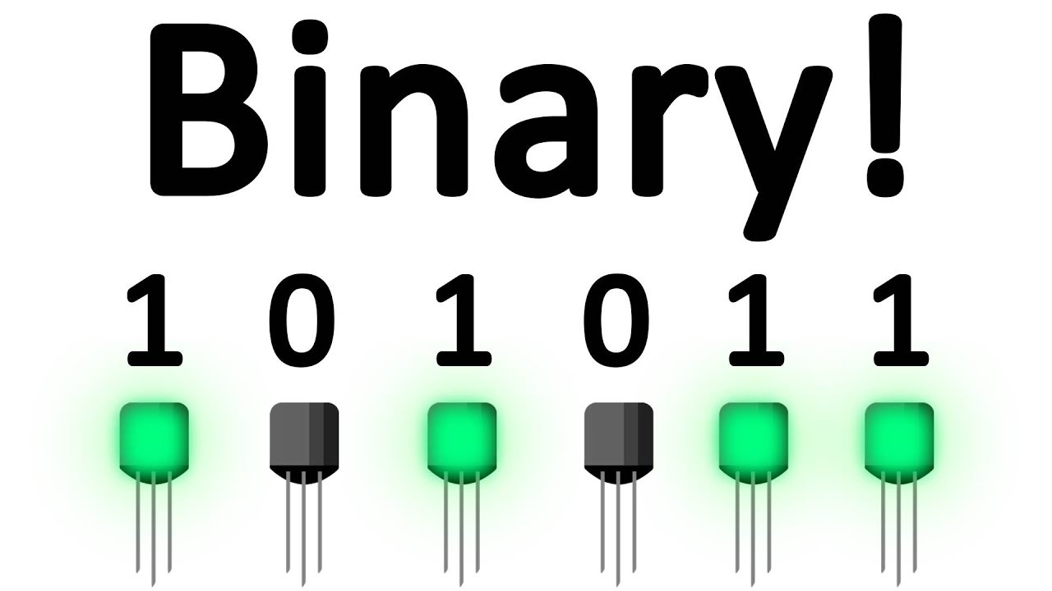

A byte is used to represent memory of the computer. Modern computer uses billion and millions of bytes at the same time Table 1.1 represents

|  |  |  |
| --- | --- | --- |
| Terms |  | Number of bytes |
| Kilo bytes(KB) | 210 | 1024 BYTES(APPROXMITELY) |
| MEGABYTES (MB) | 220 | 1024 kilobytes |
| Gigabytes(GB) | 230 | 1024 megabytes |
| Terabytes(TB) | 240 | 1024 gigabytes |
| Petabytes(PB) | 250 | 1024 terabytes |

# System unit

The main unit which allows all the parts of the computer system to work together is the system unit. It contains

* Central processing unit (CPU)
* Memory unit
* Magnetic memory and disk drives
* Adapters and connectors

[https://www.google.com/search?safe=strict&rlz=1C1SQJL_enAE834AE834&biw=1366&bih=657&tbm=isc](https://www.google.com/search?safe=strict&rlz=1C1SQJL_enAE834AE834&biw=1366&bih=657&tbm=isch&sxsrf=ACYBGNRvNelH9P3lSOaWP1WYwnZsjkdjJg%3A1572796918314&sa=1&ei=9vm-Xa3nEuHKgwfCgZC4Cg&q=block+diagram+of+computer&oq=block+dia&gs_l=img.1.1.0i131i67j0l9.53128.70149..71973...12.0..4.295.4980.0j10j13......0....1..gws-wiz-img.....10..35i39j35i362i39j0i67j0i10j0i10i24.S02uoxh3Pn4#imgrc=8eS1iS2SyMCgPM:)

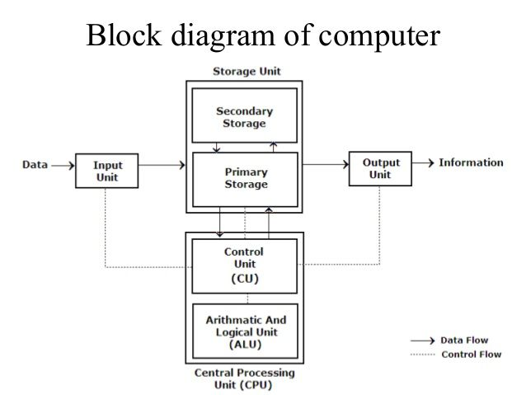

## Central processing unit (CPU) t

The CPU and the memory units are located inside the system unit. It’s the responsibility of the CPU to control all the I/O devices. All the data and information is stored in the CPU .It performs all the basic arithmetic and logical operation. The term Processor is used for the CPU It was developed by Intel in 1970s the very first processor developed by Intel was 4004 processor

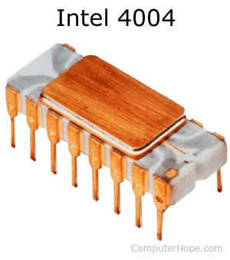

The processor securely placed on the motherboard. As they produces heat so processors are covered in heat-sink for keeping them cool and to run smoothly. The latest Version of Intel is i9

There has been a dramatically improvement in the speed of processor from past years For Example: The first Intel processor was developed in 1971 it had 2300 transistor per second it used to perform 60,000 operations. Intel Pentium has 3,300,000 transistors and completes around 188,000,000 instructions per second.

There Two main components of The CPU

* Arithmetic Logical Unit
* Control Unit

**Control unit:**

It is the most important part of the CPU. The work of the control unit is to control and coordinate all the activities of all the units in the computer system. It performs this function by issuing necessary commands to respective units of the computers. Control unit and arithmetic logical unit needs temporary storage .It fetch instructions from the RAM and stores it into instruction register and move on to the ALU.

**Arithmetic And logical unit**

Arithmetic logical unit is said to be the calculator of the computer. It is the building block of the CPU. It performs all the mathematical operations (Addition, subtraction, multiplication and division) and logical operation Mostly the operations of the CPU are performed by ALU which are loaded in the registers. According to (Rouse, 2016) “A processor register (CPU register) is one of a small set of data holding places that are part of the computer [processor](https://whatis.techtarget.com/definition/processor)”. In the form of Binary numbers all information is stored and operated. It uses transistor switches as it has only two possible states ON and OFF

## Computer memory

Registers are the small storage areas in the memory units .as compared to registers CPU needs much larger area that can hold few bytes at a time they are equipped with the storage units known as the memory units which is connected with the processor .The storage devices are classified into the following types

* Main memory
* Secondary memory

## Main memory:

Main Memory is also known as the primary memory It is located on the semiconductor chip These memory chips are connected with the motherboard .it is directly accessible by the CPU and it is faster The size of a storage device is expressed in bytes.

Different types of main memory are:

* RAM
* ROM
* Internal processor

### Read only memory (ROM)

It is the permanent memory. All the important tasks are performed by the ROM. Whenever that computer is turned on ROM provides instruction to CPU during start- up or booting process another important role of the ROM is character generator .It is the non-volatile memory it means the instructions stored in it can be changed or deleted whenever the computer is turned off. Rom is also used in other electrical devices, data stored in it cannot be changed or deleted .ROM is a semi-conductor chip

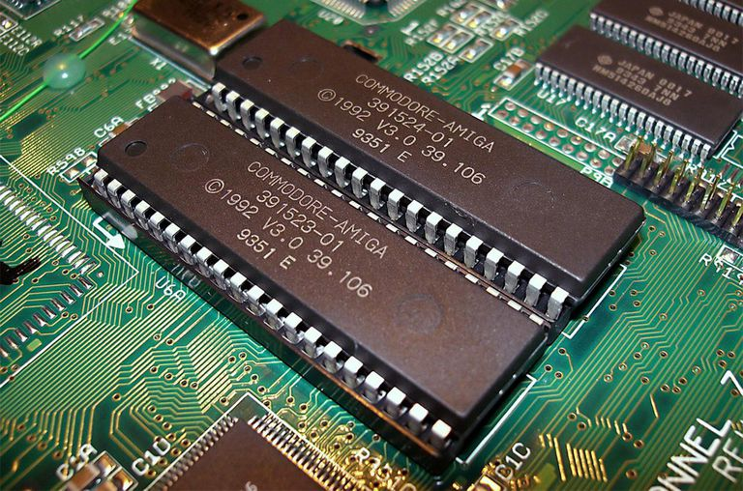

**Types of Rom:**

**PROM**: stands for Programmable read only memory. It can be programmed only once according to the requirements it is used in electronic machines that require information to be stored in permanently.

**EPROM**: (erasable programmable read only memory).The contents can be erased by ultra-violet light. It can be reprogrammed however constant erasing and rewriting can make the chip useless. **EPROM** is mainly used in Bios so that it can updated with the latest version of the program

## Random Access memory (RAM)

The major part of the main memory is RAM it is directly accessible by the CPU.RAM is not the permanent memory it is fast as compared to ROM .it is the part of the main memory in which data instructions are detained temporarily. It provides the user a working area in which user can enter and process data.in ram each data has its own memory location. RAM is also known as read-and-write memory as computers can write or store data at any time and read and retrieve from any location. As we know Ram is a temporary memory I data and instructions will be lost when the computer is turned off .so it is also known as volatile memory. RAM is a semi-conductor chip as it has no moving parts .RAM can access data at a very high speed

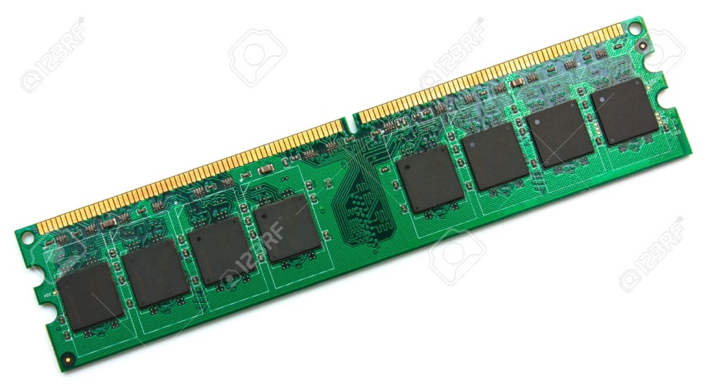

[https://www.google.com/search?](https://www.google.com/search?safe=strict&rlz=1C1SQJL_enAE834AE834&biw=1366&bih=657&tbm=isch&sxsrf=ACYBGNSXeCWIpjIHRsq-oOpYgqISEGhaNA%3A1571656662621&sa=1&ei=1pOtXbHDJc2PlwTJ3YXIAw&q=random+access+memory&oq=Rando&gs_l=img.1.0.0i67l6j0l4.7007.8781..10870...1.0..0.488.2234.4-5......0....1..gws-wiz-img.......35i39j0i3.30_V6JfJ1p4#imgrc=FNOHI-xaHCNiiM:) >Accessed 21, 2019

**Types of RAM:**

**Static random acess memory** : is often used in system cache . it is said to be static becuase it doesnot need to be refreshed SRAM is faster in speed as compared to DRAM.

**Dynamic random acess memory**: by its name we know that it needs to refreshed each time or the content will be lost. DRAM is used in the main memory .Advertised smartphone or personal computer has 4GB RAM or 12 GB RAM these all DRAM

**Single in –line memory modules (SIMMS)**

Computer power is affected by the capacity of RAM . By the help of RAM run faster .for running a program it is not neccesary to load all the program into the main memory however greater part of the program is loaded in the main memory . Many RAM chips are installed on the circuite borad these RAM chips are wired together to form single module in large memory known as single in line memory modules .Slots are avaliable o the motherborad for inserting SIMMS . 32 PINS and 72PIN SIMMS are the two tpes of simms

**Dual in-line memory modules**

The popular SIMMS were replaced by DIMMS. As compared to simms dimms provides larger capcity . It has wider data bus thus have higher rates of data trnsfer .we can simply expand RAM capacity by simply plugging in more DIMMS.168 pin DIMM and 184 and 240 pins are the types of DIMMS

Table COMPARISON BETWEEN SIMM AND DIMM

|  |  |
| --- | --- |
| SIMM | DIMM |
| Connected with the pins on the sides | Whereas it is independent |
| It can channel 32-bits | It can channel 64-bits |
| Power consumption :5 volts | Power consumption: 3.3 volts |
| Storage = 4MB to 64MB | Storage=32mb to 1GB |

## Internal processor

These memories are directly accessible by the CPU

**Cache memory**: It is a semi-conductor chip with the small amount of high speed which is present on the motherboard it stores some active portion from the memory.it lies between the processor and main memory. If any information is required by the processor it will first look into the cache memory if its nit there then it will fetch from main memory.T here three types of cache memory:

* Level 1
* Level2
* Level 3

Level 1 cache memory is built in the microprocessor

Level 2 and level3 are the two separate chips on the motherboard

Figure shows example of cache memory

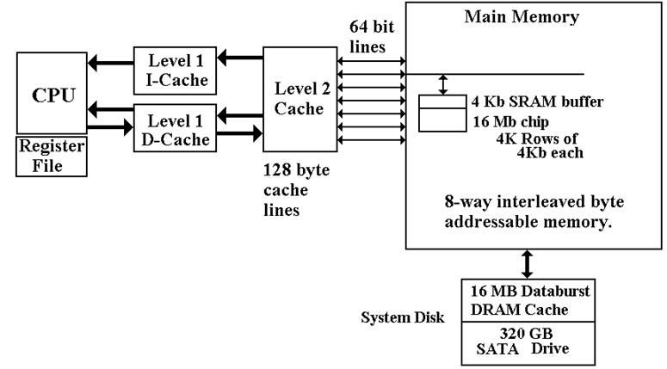

[https://www.google.com/search?q=c](https://www.google.com/search?q=cache+memory&safe=strict&rlz=1C1SQJL_enAE834AE834&sxsrf=ACYBGNQXgztxDvFXoz8zQRoLkHVFzAurIA:1571852024212&tbm=isch&source=iu&ictx=1&fir=5Sp7JaJaKT0UaM%253A%252C6f3jyBE2UQJLAM%252C%252Fm%252F01zyw&vet=1&usg=AI4_-kQ0KYC3_aZ1X7KG5Y4zESZAA0fraw&sa=X&ved=2ahUKEwiRpquM9bLlAhWp0eAKHbGUAvAQ_B0wG3oECAkQAw#imgrc=Tu4D8Pvw_exKAM:&vet=1) > accessed on 23,2019

**Registers:** Registers are the small memory units. The function of the register is to temporarily store binary information and pass it on to the processor during the execution of the program

Commonly used registers are

* Accumulator register
* Instruction register
* Data register
* Memory address register
* program counter

# Secondary Memory

Secondary memory is also known as backing storage it is not directly accessible by the CPU.IT IS PERMENANT MEMORY as it is not directly accessible by the CPU information is first copied in to the RAM and then conveyed to the CPU. Secondary storages are of two types:

* Sequential access
* Direct access

Sequential access storage: Data is accessed one after other in a proper sequence until it reaches to their desired data. This takes a lot of time and is much slower in speed compared to direct access for example: Magnetic tape

Direct access storage: data is accessed directly they are also known as random access memory it is faster in speed as compared to sequential access storage Examples: flash memory and hard disk

**Types of secondary memory:**

* Magnetic tape
* Floppy disk
* Hard disk
* CD-ROM
* PORTABLE HARD DRIVES
* Flash memories

# Buses

In a computer large amount of data and instructions have to move from one unit to another. Buses are the set of parallel wires it provides an electrical path among control unit ALU and other hardware parts which are attached to the circuit board .Control commands and address data have separate paths

There are three types of buses

* Data bus
* Address bus
* Control bus

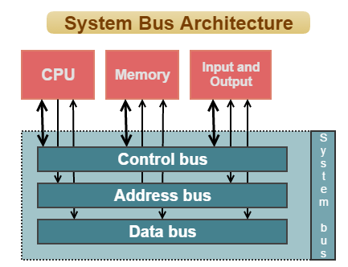[https://www.google.com](https://www.google.com/search?q=buses+in+cpu&safe=strict&rlz=1C1SQJL_enAE834AE834&sxsrf=ACYBGNQh-IAwIlHQKMvgd5-8jq8VdW9t1A:1571856125551&source=lnms&tbm=isch&sa=X&ved=0ahUKEwiglIGwhLPlAhUi8-AKHSskBDYQ_AUIEigB&biw=1366&bih=608#imgrc=VFNnrjjCiY2DsM:) >accessed 23, 2019

**Data bus**: DATA bus is an electrical bus that connects CPU with the main memory and the other hardware devices .number of the wires effect the speed through which the data is travelling between the components. Each wire can transfer one bit at a time so therefore 8wires bus can transfer 8 bits at a time thus the speed of the computer depends upon the bus width

**Address bus:** The second bus is the address bus .The purpose of the address bus is to send address from one part to another. The address bus carries data/ information in set of wires same like data bus. The number of lines tells the maximum number of memory address For example: CPU with 16 bit address bus can address 216 =65,536 bytes =64Kbytes

**Control bus**: It controls all the other units of computer system. It sends control command to all the system. Control unit transfers data from the main memory to ALU for processing

## PORTS

Several pins and plugging which connects input and output devices with the CPU is known as ports. It is generally called the interface provided at the back of the computer system ports are the direct link to the CPU. There are various ports each have different capabilities and uses

Following are the different type’s ports

* Serial ports
* Parallel ports
* PS/2ports
* USB PORTS
* HDMI PORT
* FIREWIRE PORT

Serial port:

It transfer one bit data at time early computers ,serial ports have 9 to 25 pins in which one pin used for data transmission and rest of them transmitted signals these are called COM1, COM2, and COM3. Mostly serial ports are used to connect modem USB ports have replaces serial ports.

[https://www.google.com/search?q=serial+port&safe=strict&rlz=1C1SQJL_enAE834AE834&sxsrf=ACYBGNSTJzU8KrKZyvGTn-M:](https://www.google.com/search?q=serial+port&safe=strict&rlz=1C1SQJL_enAE834AE834&sxsrf=ACYBGNSTJzU8KrKZyvGTn-0nxYXJ_6Q_4Q:1572030899057&tbm=isch&source=iu&ictx=1&fir=EKmhMBs37z1EkM%253A%252CaaX73DBl7ihNNM%252C_&vet=1&usg=AI4_-kTJgnK_xYIGs51AmlAYwt0wrjHwig&sa=X&ved=2ahUKEwiYsMG6j7jlAhViAGMBHdTfCd4Q9QEwAHoECAUQAw#imgrc=EKmhMBs37z1EkM:) >accessed 23, 2019

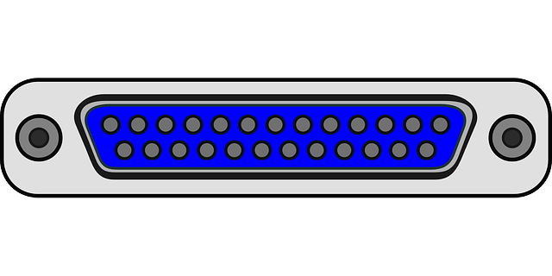

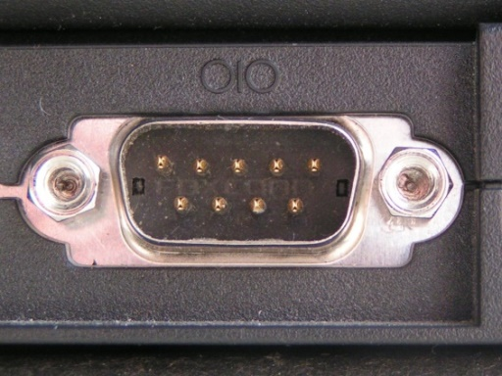

Parallel ports: Theses ports provides faster transmission of large amount of data Parallel ports have 25 pins in which pins transmits one byte of information and other wires are used to transmit control signals. Parallel ports can transmit larger amount of data at faster rate as compared to serial port.LPT2 LPT3 are examples, these are also replace by USB port

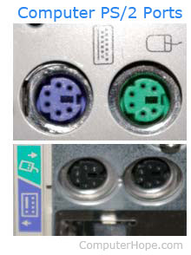**PS/2 port:**

These ports are also known as keyboard and mouse port or (personal / system2).PS/2 was developed by IBM in(1987). These ports are round shaped as shown in figure it has 6 pins and these ports can still be found in PCs

<https://www.computerhope.com/jargon/p/ps2.htm>> accessed 2019

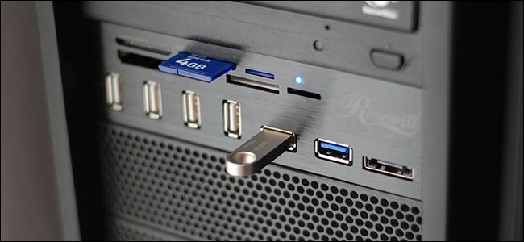**USB ports**

USB ports are used in all the modern computers. Stands for universal serial bus it is very fast, it is used to connect computer devices such as printer, mouse ,flash drives and camera etc. USB ports are plug and play ports it automatically detects which device is connected to the computer and automatically install the drivers whenever the device is connected to the computer

[wizimg.......0i67j0i24.S9zlFVYBDnY&ved=0ahUKEwjAq8mQlrjlAhWDURUIHRSWB8EQ4dUDCAc&uact=5#imgrc=1jEftqposO3SAM:](https://www.google.com/search?safe=strict&rlz=1C1SQJL_enAE834AE834&tbm=isch&sxsrf=ACYBGNRYU_MSryWIxKxbHVkSqQ3ytxf06A%3A1572032690154&sa=1&ei=slCzXcCKCYOj1fAPlKyeiAw&q=usb+port+on+cpu&oq=usb+port+on+cpu&gs_l=img.3..0.4912.7470..8409...0.0..0.269.1600.2-7......0....1..gws-wizimg.......0i67j0i24.S9zlFVYBDnY&ved=0ahUKEwjAq8mQlrjlAhWDURUIHRSWB8EQ4dUDCAc&uact=5#imgrc=1jEftqposO3SAM:) .accessed 23, October 2019

## Input devices and output devices

Input devices Gives data and instruction to the computer.so that it can process. And output devices display that processed result on the screen input devices, allows giving input and output devices can only receive data and information and display on the screen. The data entered by the user through (keyboard) and generated by the computer to show an output, they are referred as I/O devices.

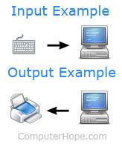For example: The data entered through the keyboard directs electrical signals. Which is accepted by the computer as input these electrical signals are interpreted by the computer (and displayed as output) on the screen.

<https://www.computerhope.com/issues/ch001355.htm> >accessed 3, November 2019

So input devices can send data but they cannot receive data from other devices.

Following the different types of input devices:

* Mouse
* Keyboard
* Joystick
* Scanner
* trackball

Following are the types of output devices

* monitor
* projector
* printer
* plotters
* speakers

# 1.2 Networks

A combination of servers, devices, networks, computers and many other peripheral devices that are used to connect computers or other devices to share data is known as network. For example, Internet and this example would be very excellent because it connects billions of people around the world.

Examples of network devices include:

* Desktop
* Consoles,
* Firewalls
* Repeaters
* Switches
* Smartphones
* Tablets
* Webcam etc.

**ADVANTAGES OF NETWORK:**

There are many advantages of network; few of them are as follows:

1. Allows sharing of printers; saving money
2. Allows obtaining Site Licenses rather than buying expensive standalone licenses
3. Allow users to share files easily
4. Allow network users to connect through email
5. Allow each user to backup data easily.

**DISADVANTAGES OF NETWORK:**

1. Networking setup would be costly
2. It is very difficult to maintain large networks
3. Server breakdowns can lead to the blockage of accessing the files
4. Connected computers over networks can spread viruses easily
5. Hacking would be done easily through connected networks

## Types of network

* Network Size
* Network topology
* Transmission media
* Structure /Management methods

There are many types of networks, but the most vital types of networks are

**LAN (Local Area Network)**

LAN is considered as the most easiest and real type of network. Many low-voltage devices and computers from remote areas are connected using LAN which is used to share big amount of data within one or more buildings.

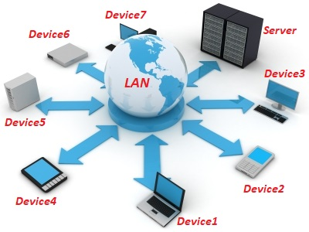LAN speed today is approx. 100 to 1000 Mbps. LANs are of different types, a smaller LAN can accommodate two or three computers, while a bigger LAN can accommodate thousands of computers.

**WAN (Wide Area Network)**

It is approximately same as LAN but the difference is that it is connected with the computers having longer distances. Just like LAN, it also allows low-voltage devices to connect with each other from miles away. It is a high-speed and a bit expensive networking system.

In other words, WAN is also made as a connection of different LANs connected with each other through landlines, radio-waves or it could be accessed by a public.

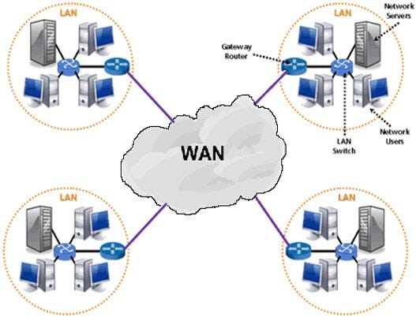

[https://www.google.com/search?safe=strict&rlz=1C1SQJL_enAE834AE834&biw=1366&bih=657&tbm=isch&sxsrf](https://www.google.com/search?safe=strict&rlz=1C1SQJL_enAE834AE834&biw=1366&bih=657&tbm=isch&sxsrf=ACYBGNRGHsZ34khdBEVTAqA7J014Adagsw%3A1572789616785&sa=1&ei=cN2-Xf3IL-zjgwfntbvQBQ&q=wide+area+network&oq=area+network&gs_l=img.1.3.0l2j0i7i30l8.129716.130332..133307...0.0..0.206.962.0j4j1......0....1..gws-wiz-img.......0i67j0i10.96Z1_3Z_fFU#imgrc=ZNF24YvpG_eDLM:)

**MAN (Metropolitan Area Network)**

MAN is a network that is bigger than LAN but smaller than WAN but it has the abilities of both the networks. It spans a wide geographic area; a town, city or maybe a campus. This type of network can connect different computers that are within the same or different metropolises. It is suitable for high speed connections, but at the same time it is difficult to retain MAN. The cost of MAN is also high and could be either owned by a company or no. A best example of MAN could be a telephone organization that provides high-speed DSL lines to their users within cities or outside.

## Transmission media

In data communication method, a transmission medium is known as a physical connection between the transmitter and the receiver. In transmission media we have mainly 2 broad classifications:

* Guided media and
* Unguided media

Guided media provide high speed quality and are very secure. This type of media is mainly used for shorter distances.

**Guided media is further classified into three different types:**

* Twisted pair cable
* Coaxial Cable
* Optical Fiber Cable

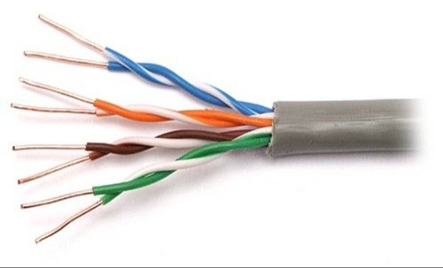

### Twisted pair cable

By name we get to know that that the wires are twisted together in a pair .There are two types of twisted pair cable STP (Shielded twisted pair) and UTP (unshielded twisted pair cable).Twisted cables consist of two copper thin wire twisted together the purpose of twist in the wire is to reduce signal interface compared to coaxial wire it is much cheaper

[https://www.google.com/search?safe=strict&rlz=](https://www.google.com/search?safe=strict&rlz=1C1SQJL_enAE834AE834&biw=1366&bih=657&tbm=isch&sxsrf=ACYBGNRaDqF-8Ky5vte2_7-D_7UGwZoMXA%3A1572793883385&sa=1&ei=G-6-XZ2VF-iHjLsPgu-W2Ag&q=twisted+pair+cable&oq=twisted&gs_l=img.1.0.0i67l6j0l4.637149.641271..643203...1.0..4.264.2535.0j5j7......0....1..gws-wiz-img.....10..35i39j35i362i39.L_BCyhrjCOA#imgrc=Fdwr568gz1xfRM:)

### Image result for coaxial cableCoaxial cable

Coaxial cables is used long distance transmission .It can transmit data at a very high speed of (10 to 100 megabits) Example : Coaxial cables are used in telephone company to transmit data over long distance They are packed into a large cable, Hundreds and thousands of calls can be handled at a a time. Coaxial cables are made up of two conductors inner and the outer .Inner conductor is made up of copper and outer conductor is made up of plastic.

### Optical fiber

Optical fiber uses light to send data from one place to another. The existence of light is taken as (I1bit) and absence of the light is taken as (0).Optical fiber has much greater bandwidth. Fiber cables are used for long distance as there is no signal attenuation. It can transmit data at a very high speed; speed transmission is much more than 100 mbps.

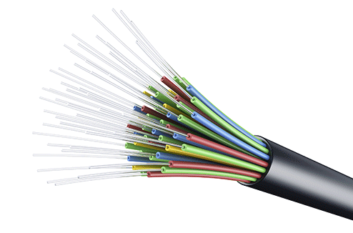

[:](https://www.google.com/search?safe=strict&rlz=1C1SQJL_enAE834AE834&biw=1366&bih=657&tbm=isch&sxsrf=ACYBGNQVSIPOZ5kbsUy7U2P5Yl-s_M-s6A%3A1572792744994&sa=1&ei=qOm-Xf20PJaHjLsP_tWe4AM&q=fiber+optic+cable&oq=FIB&gs_l=img.1.0.0i67l10.1131676.1134744..1137042...1.0..4.278.1765.0j1j7......0....1..gws-wiz-img.....10..0j35i362i39j35i39.8r7YvTpVYkE#imgrc=KxsaLjKZOCs6hM:)

**Unguided media** also known as wireless or unbounded transmission media. It sends electromagnetic signals which do not require any physical medium.

Unguided media is further divide into three types:

* Communication satellites
* Microwaves
* Infrared

<https://www.geeksforgeeks.org/types-transmission-media/>

**Microwave**

In microwave transmission signals travels through open space. It transmits information through transmitter which are installed on the top of the buildings Relay stations are spaced approximately 30 miles apart (For long distance).For transmitting information over long distance signals are amplified and transmitted from station to station.

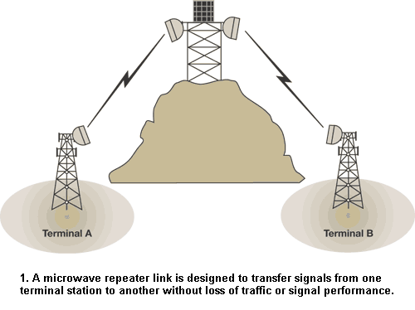

[https://www.google.com/](https://www.google.com/search?safe=strict&rlz=1C1SQJL_enAE834AE834&biw=1366&bih=657&tbm=isch&sxsrf=ACYBGNQLfuMbh6llxRnxhKXvj3TjGwgazw%3A1572794527802&sa=1&ei=n_C-XbbPMIe1U7ilgOgM&q=microwave+transmission&oq=microwave+tr&gs_l=img.3.0.0i67j0l9.1553171.1559641..1561472...1.0..4.395.3936.0j6j9j2......0....1..gws-wiz-img.....10..35i362i39j35i39.gVq6oaD3dfA#imgdii=wfnRYfwt2i83mM:&imgrc=VciwPnBQpYgxLM:)

**Communication satellites**

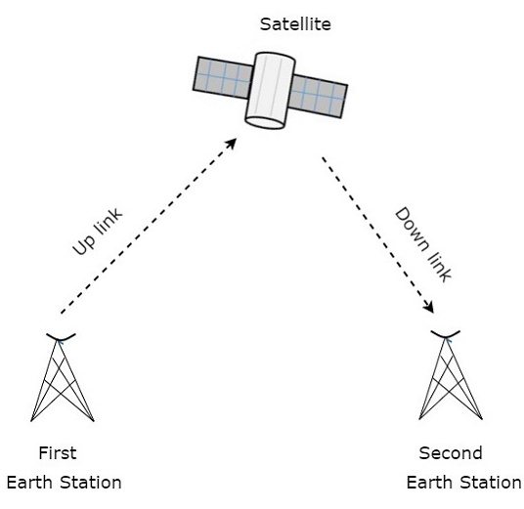**S**atellites are positioned approximately 22,000 miles above the Earth. Stations beams signals to the satellites and the satellites retransmits those signals to another station. Satellite communication is perfect for long distance communication. At a very high speed data is transmitted from place to another there have been dramatically increase in the use of satellites

[https://www.google.com/search?safe=strict&rlz=1C1SQJL_enAE834AE834&tbm=isch&sxsrf=ACYBGNQN](https://www.google.com/search?safe=strict&rlz=1C1SQJL_enAE834AE834&tbm=isch&sxsrf=ACYBGNQNhMJvdJhUpM693pvYwrK01VrmEA:1572798097783&q=communication+satellite&chips=q:communication+satellite,g_1:diagram:b_VsGO9tADE%3D&usg=AI4_-kQA6iu1nlaq648bCjZoWrQAps8pag&sa=X&ved=0ahUKEwj4yK-_uc7lAhXj8eAKHecSBoUQ4lYIMCgD&biw=1366&bih=657&dpr=1#imgrc=ISH0ctGupDGhzM:)

## Network topologies

Network Topology refers to the arrangement of network nodes and connection between them. A node represents any device on network.

Following are the two ways of network geometry:

* **physical topology**
* **Logical topology.**

**Physical Topology**

It refers to the physical interconnection between local area network, the way to connect physical devices with cables in a network (Types of caballing used) organizes physical topology. Or

The physical connection (Ethernet, DSL) between a networks layout of nodes.

Following are the different types of physical topology

* Star topology
* Bus topology
* Ring topology
* Mesh topology

## Star topology

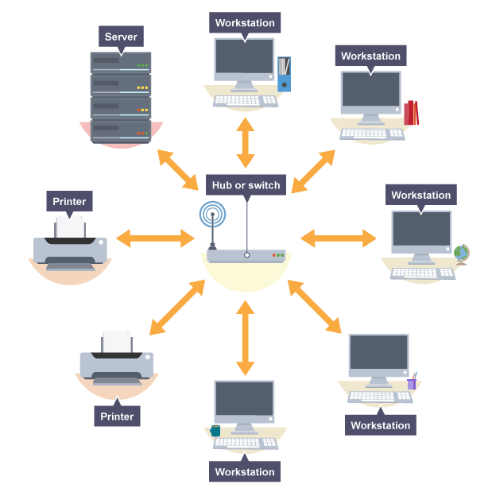In star network topology each network node is connected to central device known as hub. It is better to use switch. In this topology different nodes are known as host .Each host is connected to a central device known as hub, in this topology, if nodes want to communicate with a central node, then they pass on the message to the central server and the central server forwards their messages to the different nodes.

**Advantages of star topology**

* Easy to install and wire
* Easy to detect and remove faults
* Easy to modify
* Hub /switch can be progressed easily

**Disadvantages of star topology**

* Failure of the hub causes entire network to go down
* It is expensive
* HUB/Switch fails the whole networks goes down because all the nodes are connected with the hub
* As all the nodes are connected with hub so the performance of the nodes depends on the hub

## Bus topology

All the nodes are connected to a single cable which is known as the backbone of the network. Terminators are installed at each end of the cable so that data singles does not reflects back and cause error.

**Advantages of bus topology**

* Easy to connect with other peripheral devices
* Small networks
* Bus topology is easy to understand
* It is really cheap (less cables required)
* It is very easy to install

**Disadvantages of bus topology**

* Not suitable for large networks
* If the main cable gets damaged the entire network goes down
* Security risk (data can be seen by other users)
* It is slower

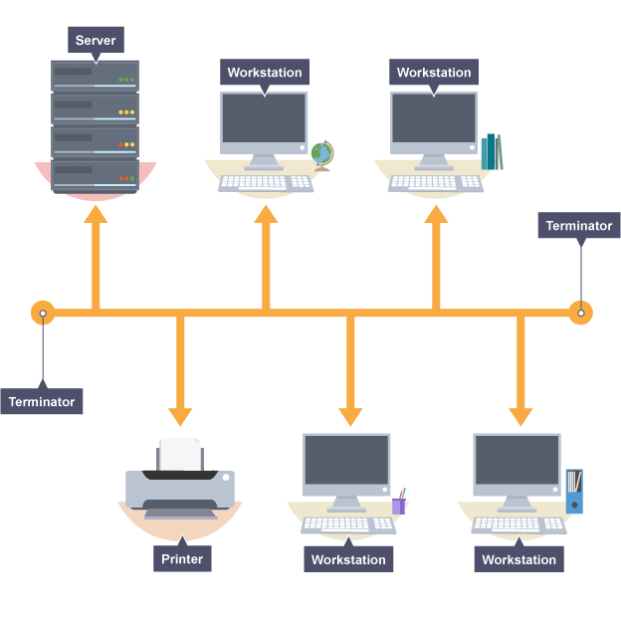

## Ring topology

By its name we get to known that it is shaped like a ring. It is made up of an unbroken circle of network node that means each node is connected to other node.

There are two types of ring topology

* Unidirectional
* Bidirectional

**Unidirectional**: in this data traffic is controlled either in clockwise or anti clockwise thus it is also known half-duplex network.

**Advantage of ring topology**

* Easy to install and wire
* Less chance of data collision as data flows in only one direction
* Not costly
* Equal access to all

**Disadvantage of Ring topology**

* Slower than other topologies
* In unidirectional data should pass through each node
* If the ring is broken at any point the entire network goes down.

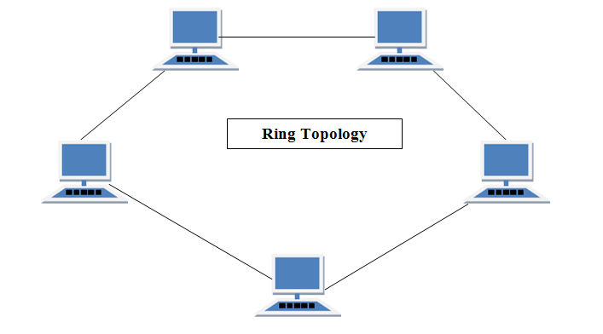

<https://www.studytonight.com/computer-networks/network-topology-types>>accessed 3, November 2019

## Mesh topology

In mesh topology all the nodes are connected to each other it is (point-to-point) connection with other nodes. For Example: If 5 nodes are connected to each other, four ports required.

There are two ways to transfer data in mesh topology:

* Routing
* Flooding

**Routing**

In routing it finds the shortest way to reach to its destination. Suppose if the link between the nodes is broken it avoids those nodes it logically finds a way to transmit data.

**Flooding**

Same data is transmitted to all the nodes hence there is no logical routing in this. The network is strong so there is no chance of losing data but it leads to undesirable load on the network

**Advantages of Mesh topology**

* Faults can be found easily
* Mesh topology provides high security

**Disadvantages of mesh topology**

* It is expensive as compared to the other topologies
* Installation is hard

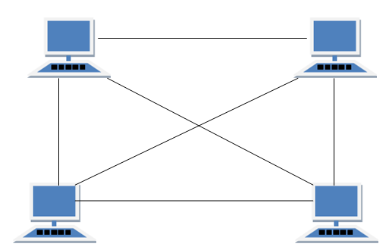

<https://www.studytonight.com/computer-networks/network-topology-types> >accessed 3, November 2019

# Logical Topology

Logical topology is technique in which signals act on the network media .It is the logical connection between the nodes. Through which data passes from one device to another without any physical connection. Logical topology is bound by the network protocol which tell the direction of data Ethernet protocol is commonly used .When a network is designed the logical parts refers to the (IP addressing).

According to the scenario for infinity car company wide area network would be the best because in wide area network

# 1.3) Assess the function of components within a chosen computer system

|  |  |
| --- | --- |
| System 1 | System 2 |
| Acer aspire A315-51 | HP ENVY |
| Processor : Intel CORE I5 | Core i7 |
| Computer type: Laptop | Computer type: touch screen convertible Laptop |
| Intel (r) i5-7200U | I7-8550U |
| 64 bit operating system | 64 Bit operating system |
| X64-based processor | 64 Based processor |
| Windows 10 | Windows 10 pro 64 |
| RAM :6GB | 16 GB RAM |
| 7TH generation | 8th generation |
| Display size: 15.60 inch | 15.7 inch |
| Hard Disk 1TB | Hard disk: 1 TB 7200 RPM SATA |
| Processor speed:2.50GHz- 2.71GHz | Processor speed: 1.8 GHz base frequency, up to 4 GHz |
| Battery capacity (up to hours) 6 hours | Battery capacity (hours ) 11 hours |
| 4MB cache | 8MB cache |
| Wi-Fi standard :802.11ac | Wi-Fi standard: : 2x2 802.11ac |
| No touch screen | TOUCH SCREEN |
| Price:340$ | Price: 649$ |
| 4 battery cell | 4 battery cell |
| Great battery life line for everyday use | Faster battery charge approximately 50% in 45 minutes |

According to the senior for the infinity car company HP envy x 360 would by the best laptop as it has corei7 and it is 8th generation it is really good for office everyday use and it is budget friendly too. It 2 in 1 the user can use it as laptop and tablet to compared to other laptop this laptop has better resolution . And it is faster. It will not stuck when there are a lot of tabs open. Battery charging is fast compared to Acer.

# 1.4 Peripheral Devices

According to (techopedia, 2019) “A peripheral device is an internal or external device that connects directly to a computer but does not contribute to the computer's primary function, such as computing It helps end users access and use the functionalities of a computer”

Following are the types of peripheral devices

* Input devices
* Output devices

## Input devices

Input devices are those devices through which Data and instructions are given to the computer. Input devices are not only used to enter data into the computer but also the instruction that tells the computer what to do and how to do. Keyboard is the oldest and the most common input device. A Computer can have more than one input devices attached to it; the input given into the computer is first converted into binary and the passed to the CPU because as we all know computer can understand only binary language. Following are the examples of Input devices

* Keyboard
* Mouse
* Joystick
* Trackball
* Scanner
* Light pen

### Keyboard

it is use to enter data, standard arrangement of the keyboard is (QWERTY).Keyboard is connected with the computer with a dedicated keyboard port that contains signals as well as power lines. While using the keyboard we will notice a bright flashing line which is known as cursor. Key pressed, will enter the character were the cursor is placed. There are two styles of keyboard mostly used by microcomputers.

* PC/XT style keyboard
* AT style keyboard: It has 101 keys

<https://www.google.com/search?q=keyboard&safe=strict&rlz=1C1SQJL_enAE834AE834&sxsrf=ACYBGNRK1DYP8OXLEpn30FYKMlmNMRecnA:1572873740368&source=lnms&tbm=isch&sa=X&ved=0ahUKEwjFysik09DlAhXJ34UKHZrnCWoQ_AUIEigB&biw=1366&bih=657#imgrc=fx7TZ31vazq7LM:> 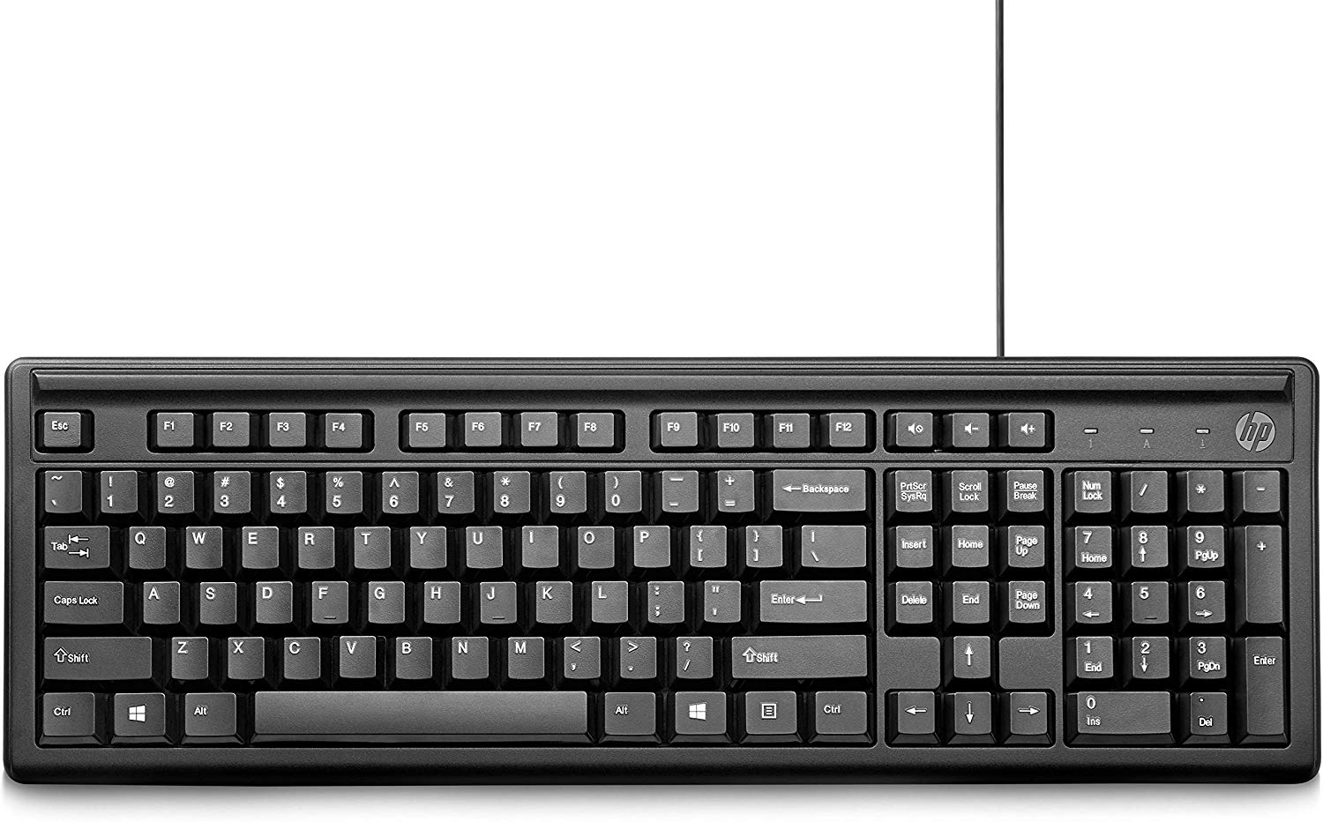

### Mouse

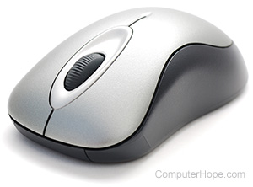A mouse is pointing device that rolls on the flat surface. Mouse is small hand held device with two or three buttons which is connected with cord. Cursor of the mouse is called the mouse pointer. As you move the mouse on the flat surface the pointer also moves along. The operations of the mouse is clicking, dragging, double clicking, and selecting the desired object.

Types of mouse

* Mechanical mouse:
* Optical mouse :
* Wireless mouse

<https://www.google.com/search?q=types+of+mouse&safe=active&rlz=1C1SQJL_enAE834AE834&sxsrf=ACYBGNSXOtWgPr3GolfqV4S1GmYWxZ3ADQ:1572874792385&source=lnms&tbm=isch&sa=X&ved=0ahUKEwjxppqa19DlAhVEzIUKHR5OCs0Q_AUIEigB&biw=1366&bih=657#imgrc=bCjJpf7N83ipOM:>

## Image result for joystickJoystick

Joystick is also a pointing device. It consists of stick that pivots on spherical ball on its base. As stick is moved the angle and direction is recorded and the cursor moves along. It is generally found with microcomputer and is used to play games, computer aided design (CAD) system and for educational purposes.

<https://www.google.com/search?safe=active&rlz=1C1SQJL_enAE834AE834&biw=1366&bih=657&tbm=isch&sxsrf=ACYBGNQPJ2RwTIVPJu7UegIrIdzSPlJsRw%3A1572874936707&sa=1&ei=uCrAXbzmKrOBjLsP0pKI2AE&q=joystick&oq=joystick&gs_l=img.3..0i67l5j0l5.1829093.1832130..1832529...1.0..0.302.1655.0j6j1j1......0....1..gws-wiz-img.....10..35i362i39j35i39.0suMEWaskDI&ved=0ahUKEwi8ooPf19DlAhWzAGMBHVIJAhsQ4dUDCAc&uact=5#imgrc=BXzfcUGTde_vcM:>

## Scanner

It is a type of input device for digital image. Scanners convert every bit of image in to electrical pulse. A software known optical character recognition (OCR) is installed to translate scanned documents Scanners are used to scan and copy the picture. The first scanner is developed in 1957. There are two types of scanners

* Drum scanner
* Flatbed Scanner

Now a day’s flatbed scanners are commonly used .It is composed of glass plane under which there is bright light array an image to be scanned is placed on the face down on the glass.

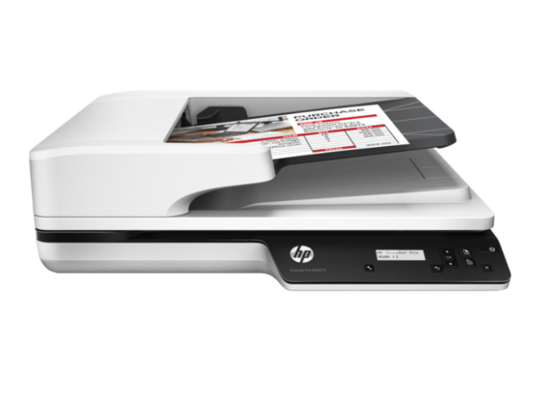

<https://www.google.com/search?safe=active&rlz=1C1SQJL_enAE834AE834&biw=1366&bih=657&tbm=isch&sxsrf=ACYBGNS8isqJimda0Y2X5tY7CxBVP7lUeQ%3A1572876770252&sa=1&ei=4jHAXefwDt3RgwezyarQBw&q=scanner&oq=scanner&gs_l=img.3..0i67l4j0l6.946145.1056718..1058412...1.0..4.712.3954.0j5j3j1j0j2j1......0....1..gws-wiz-img.....10..35i39j35i362i39.AMIC3deVjUg&ved=0ahUKEwjn6anJ3tDlAhXd6OAKHbOkCnoQ4dUDCAc&uact=5#imgrc=M1NZbHh-w3fQNM:>

## Light pen

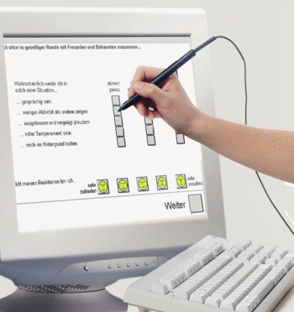LIGHT pen is also a pointing device which looks like a pen which is connected with monitor tip of the light pen has light sensitive element when the tip of the light pen is placed on the screen it detects the light form the computer identifies location of the pen on the screen. It is easy to use and we can easily draw anything on the screen but sometimes it becomes uncomfortable and may not be very accurate. First light pen was invented in1955.

<https://www.google.com/search?safe=active&rlz=1C1SQJL_enAE834AE834&biw=1366&bih=657&tbm=isch&sxsrf=ACYBGNT7I15j8HiOGEIwrn1j5THyzhuSsw%3A1572878275344&sa=1&ei=wzfAXcDQFIuKjLsPlNOBqA0&q=light+pen+pictures+of+input+devices&oq=light+pen+of&gs_l=img.3.1.0j0i8i30l2.7477.8578..11452...0.0..0.191.550.0j3......0....1..gws-wiz-img.......0i67j0i5i30.8jvmpUM9zFA#imgrc=MoJbk1grvDyMBM:>

## Trackball

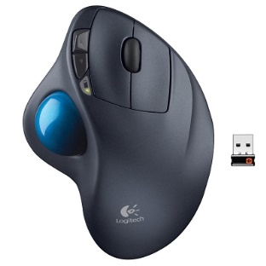Trackball is also a pointing device same like mouse. The user controls the cursor by rolling the plastic ball .Trackballs works exactly like mouse, for the execution of any command one or more buttons are pressed. Trackballs are used in laptops. According to (Klosowski, 2019) “After spending more than 120 hours testing eight trackballs during weeks of work, we found that the best trackballs are the finger-operated Kensington Expert mouse wireless trackball   and the thumb-operated Logitech MX Ergo wireless trackball. We also have budget picks—the  Kensington orbit trackball with scroll ring wireless trackball   and the  Logitech M570 wireless trackball if you don’t mind sacrificing build quality and a couple of features for a more affordable trackball”.

Following are the types of trackball

* **Kensington Expert mouse wireless trackball**
* **Logitech MX Ergo wireless trackball**
* **Y-10W 2.4 GHz Portable Finger Wireless Ambidextrous Trackball**

<https://besttopnow.com/best-computer-trackballs/>

### Microphones

It is a sound input device. For this type we need a sound card and a microphone. Microphones basically converts our voice into electrical signals and these electrical signals are send to sound card which than digitized the sound in a way that a computer can process. These soundcards can also translate the digitized sounds back to analog signals that can then be sent to the speakers

## Output Devices

The result or information processed by the computer system is known as output. Output devices provides interface between user and computer system output devices are used to communicate with the computer. Output devices can be input as well as output for example monitor gives output as visual display; a speaker gives sound as an output.

Following are the types of output devices:

* Monitor
* Printers
* Plotters
* CD-Writer

## Monitor

Monitors are also Known as visual DISPLAY UNIT. It is the most popular output device physically it looks exactly like television (TV) which can display both image and text. Image form on the monitor is formed by the tiny small dots known as pixel. A pixel determines the quality of the image greater the pixel will better will be the resolution of the image. Softcopy is displayed by the monitor because the image produced on the monitor is temporary. The size of the monitors is measured in length and diagonals Monitors are mostly of 4:3. Monitors are of two type’s black and white and colored monitors.

Following are the type’s latest monitors LCD, CRT VGA and SVGA.

* Colored graphic adapter (CGA) displays four colors at a resolution of (320 by 200 pixel)
* Enhanced graphic array adapter (EGA) displays 16 colors
* Video graphic array adapter (VGA) displays 256 colors
* 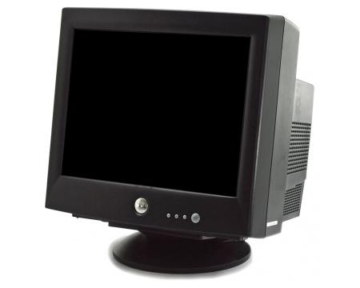Super video graphic array adapter (SVGA) it is improved version of VGA. It displays 800 by 600 to 1280 by 1024 pixels.

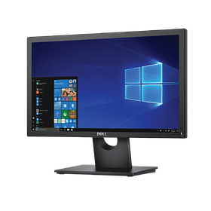

<https://www.google.com/search?safe=strict&rlz=1C1SQJL_enAE834AE834&tbm=isch&sxsrf=ACYBGNSrFz2uuLemq2eNAlgvA_G1purAiA:1573666431245&q=monitor&chips=q:monitor,g_1:computer:BgZKkDEAg2U%3D&usg=AI4_-kTeFEofVxM1L60DZMTzmWwVVl09AA&sa=X&ved=0ahUKEwiT94Ol3OflAhWABWMBHSjdAl8Q4lYIKigA&biw=1366&bih=657&dpr=1#imgrc=DX2NOxU_Yjv2QM:>

<https://www.google.com/search?safe=strict&rlz=1C1SQJL_enAE834AE834&biw=1366&bih=657&tbm=isch&sxsrf=ACYBGNR4w2ig8eY1o5amxC_2gZk0_mTT0g%3A1573667099542&sa=1&ei=G0HMXfLEIPuejLsP3MaK0Ao&q=c+r+t+monitor&oq=r+monitor&gs_l=img.1.1.0i8i30l6j0i8i10i30j0i8i30l3.47586.48362..53196...0.0..0.244.1099.0j1j4......0....1..gws-wiz-img.FrdGOeYkDJ4#imgrc=J0RkMlBFhqSUlM:>

## Printer

Printers are the type of output device which prints the information displayed on the screen on to the paper they are used to produce hardcopy these are classified into two types impact printer and non- impact printers.

Printers

Impact

Non- impact

Daisy wheel

Dot matrix

Laser printer

Thermal printer

Ink jet printer

### Impact printers

Impact printer’s works like a typewriter these printer uses metal pins which strike on the ribbon between the paper and the print heads Due to this impact printer are noisy. The printing Speed is slow. In these types of printers there is a physical contact between the printing surface and the printers. They produce a lot of sound

#### Dot matrix printer

The dot matrix printer is an impact printer. It uses tiny pins arranged to hit the ribbon and the paper. In dot matrix printer each letter is formed with combination of dots. A dot matrix printer has 9, 18, 24, and 32 pins arranged vertically in a print head. The dot matrix printer arranges pins to print dot that forms character and all kind of images. A normal dot matrix Pinter speed is 50-600 character per seconds. This is the cheapest and the nosiest printer. They are Uni- or- bi directional. The printing qualities of these printers are really poor. They are really suitable for low printing copy

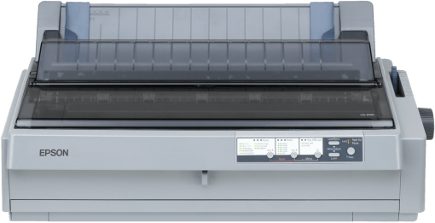

#### Daisy wheel printer

Daisy wheel printer uses flat disk or wheels with petal like projection each with different character at the tips. The wheel rotates to bring desired characters into the position. A character is formed when the hammer strikes the petal under it. Daisy wheels are available in several formats for example bold italics. Compared to dot matrix it is much slower, as the printer wheel takes more time to bring the character in position but the printing quality is better than dot matrix printer.

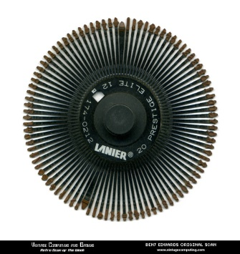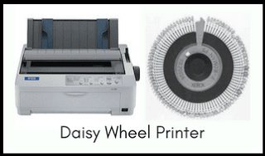

### Non-impact printer

Non- impact produces image without having physical contact with printing surface they are fast and produces no sounds while printing .These printers uses new methods that have improved printing quality and speed

#### Inkjet printer

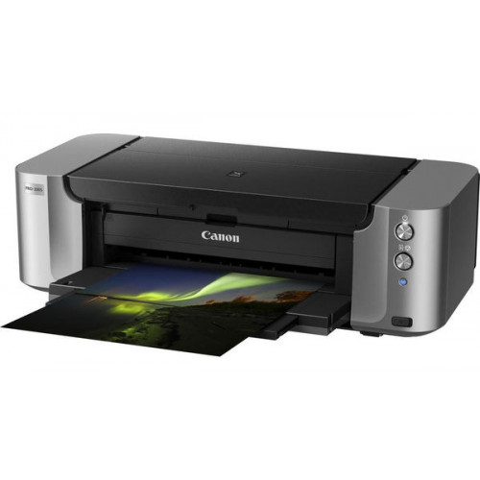Inkjet printers works exactly like dot matrix printer except the ink jet printers have fine nozzles instead of tiny pins. These nozzles spray a steam of ink onto the papers because the ink is put directly on the paper, therefore, these printers requires ink in reservoirs instead of ribbons. Since there is no mechanical movement involved, hence these printers are much quieter and have speed of about 200 characters per seconds. Ink jet printers are also available which have more than one ink reservoir, each of different color

<https://www.google.com/search?safe=strict&rlz=1C1SQJL_enAE834AE834&biw=1366&bih=657&tbm=isch&sxsrf=ACYBGNRuebj0re8PS9gzrMf9ElEmI90PPQ%3A1575210035965&sa=1&ei=M8zjXfPGOpqQ1fAPys2qsAY&q=inkjet+printer&oq=ink+jet+&gs_l=img.3.0.0i10i67j0i10l5j0j0i10j0i10i67j0i10.212061.220527..222716...4.0..0.226.2109.0j1j9......0....1..gws-wiz-img.....10..35i39j35i362i39j0i67.4NnUCeXnJcU#imgrc=dQkKlmXibkN1PM:>

#### Laser printer

Laser printers are the fastest non-impact. These printers are laser and electromagnetic and have printing speed greater than 20,000 line per minute. These printers use laser beam and dry powdered printing ink. These printer contains photo conductive drums which are charged completely first then a laser beam is used to discharge the selected areas on the drum. These discharge areas represent the white areas of the printed documents and the printed areas are charged areas. The dry powder is known as the toner. The drum rotates and transfers the ink on to the paper. This has high electrical charges in the end a heated roller is passed on to the paper to fix the toner on the paper these printers are also like dot matrix pattern. Laser printer are very fast as compared to other printer and can printer four papers at a time.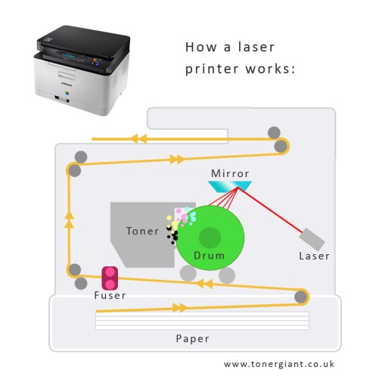

<https://www.google.com/search?safe=strict&rlz=1C1SQJL_enAE834AE834&biw=1366&bih=657&tbm=isch&sxsrf=ACYBGNQeU7dS2rrOclzNlahgPg0gAfzN5Q%3A1575210375960&sa=1&ei=h83jXduVOsGR1fAPnrSMsAc&q=+inside+laser+printer+&oq=+inside+laser+printer+&gs_l=img.3..0j0i7i30j0i5i30j0i8i30l2.19960.32931..34095...5.0..0.629.6939.2-13j4j3j2......0....1..gws-wiz-img.......35i39j0i7i5i30j0i8i7i30.IoyJhJZJxMg&ved=0ahUKEwib9Z7305TmAhXBSBUIHR4aA3YQ4dUDCAc&uact=5#imgrc=ZI4OdC8jjL7IZM:>

# Task 2

# 2.1)Evaluate different operating systems explaining their role in managing resources

**Operating system**

An operating system act as an interface between the user and the computer system .its is the most important software to run the computer. It manger the computer memory, computer processes, software and hardware. Without any operating system installed in the computer the programs will not be executed. The operating system occupies the major position between the user and the hardware. The end users interact with the computer with the help of the operating system. Operating systems runs in the background and act as a host and helps other application to run. It delivers variety of facilities to a computer. The operating system helps to interact with the all the output devices. It is also known as resources allocator as manages file and folder stored in the computer.

**Commonly used operating systems are**

**Windows**

Windows operating system was developed in 1980s y Microsoft cooperation it provide graphical user interface which is user friendly the user does not have to memorize the command like in DOS it allows the user to give commands through icons. Now a days, it is the most commonly user operating system

**DOS**

DOS stands for disk operating system it was developed in 1970s it is called disk operating system because the entire operating system is stored in a single disk. It is text based user interface the user had to learn the commands in order to operate the DOS. They are not user friendly BUT THEY WERE SUCCESFULL among the micro computers for many years but later they were replaced by windows operating system because they are more user friendly than DOS.

Following are some command of DOS

* RENAME: for renaming a file
* CID: to change the directory
* COPY: to copy file
* FORMAT to format disk

**MAC**

It was developed by the potato incorporation these OS are installed apple computers the latest version of IOS is XI. It is the 11th major release of the MAC. It is more secure compared to windows operating system it is expensive compared to windows operating system

**UNIX**

UNIX stands for uni-plexed information computing system it was developed in 1970s at bells laboratories research center by ken Thompson and Denies. Firstly it was developed in the C language it provides greater security and is faster than windows operating system. Computer running in UNIX operating system have less malware attacks.

**Functions of the operating system**

**Process management:** Process management is the part of operating system. A process is the program in execution. It Manages Allocation of the computer resources to various processes in the main memory process management basically describes the state and resource of the process For example: in this example process D,E,F are ready to execute the operating system will manage time for each resource

Process D: has CPU cycle (ta= 4 seconds)

Process E: has CPU cycle (ta= 2 seconds)

Process F: has CPU cycle (ta= 1 seconds)

**Memory management**

Memory management is part of the operating system the controls and manages the operation of main memory during the operation of the computers it allocates space to program that are loaded in the main memory for the execution. It keeps track of the free space in computer system. It also update the user with the memory status.

**File management**

It manages file and folder on storage devices such hard disk, USB, Flash drive. It allows the user to copy, delete, move, rename, read, and write and creating file and folder in the computer.

**I/O management**

It controls and manages all the input and output devices during the execution of the program.

**Network management**

Network management is a part of the network operating system that mange’s and monitors the resources of a network it allows the user to create a group and allocate privileges to them. It shares the networks resources and spots and fixes the network problems.

**Protection system**

It make sure that all the resources are being used according the privileges assigned by the administrator it creates accounts for the users and assign privileges s that they do not misuse the system it also provides passwords to main security.

### Types of operating system

**Batch processing operating system**

A batch operating system is software that group together the same types of data and executes them one by one automatically .it performs the same type of tasks on all the jobs in a batch in a sequence in which they appear . It provides an easy way of processing same type of jobs. For Example: at the end of month bank prints statement for each account holder the BOS makes it easy and prints all the statements one by one. The advantage of this OS is that there is interaction between the user and the computer.

Operating system

Users programing area

**Multiprogramming operating system**

In this type of operating system the software loads one or more programs in the main memory and executes them using single CPU in fact, the CPU executes only one program at a time while other program are waiting in a queue, when one program is busy with the input and output operation the CPU executes another program which is in the queue in this way it saves time of the CPU.

**Multitasking operating system**

It performs multiple tasks at the same time on the computer having single CPU. The CPU runs only one program at a time but it quickly switches between the programs and it looks like all the user programs are being executed at the same time.

**Time-sharing operating system**

Time-sharing operating system is a software that shares time between multiple CPU that are loaded in the main memory it gives a very short period of CPU time to each program one by one this short period is known slice quantum since CPU is switched at very high speed all the user get the impression of having their own CPU.it is used minicomputer or mainframe. It supports large number of users in big organization.

|  |
| --- |
| Operating system |
| Job 1 |
| Job 2 |
| Job 3 |
| Job 4 |

0

512k

**Real-time operating system**

Real time operating systems are used to control difficult system which involves lot of processing.it runs real time application and gives us immediate response it executes special types application within the specified time with high reliability these types of operating system are commonly use traffic control , space research etc.

**Multiprocessor operating system**

It controls the operation of two or more than two CPU with in the same computer system. They share the same memory and other peripheral devices they are used to perform large amount of data at a very speed. It can run single program using several other CPU. The types of computers which supports multi-processor OS sophisticated and hard to design

**Parallel operating system**

Parallel operating system is software that runs the program developed in parallel programing language. Many processors are used I the same time in this OS the task is divided into smaller and processed by multiple processor at the same time super computers uses parallel processing operating system because super computer have thousands of processors

**Distributed operating system**

A distributed operating system is software that manages the operation of a distributed system it allows execution of the application software on different computers in a network. In this system user program may run on any computer network and access data on other computer the user of this system does not know on which computer there program is being executed. It automatically balances the load of several computers in the network and it offers fast execution.

**Embedded operating system**

These types operating systems are t built in or they are already installed in the hardware of the device For example microwave oven, washing machine, Television they work automatically when the device is turned on.

# 2.2) Software and its types

**computer software** is a set of instruction that tells the computer what to do and how to do. Computer hardware are usless without computer software and similarly computer software is useless without computer hardware They should work together to obtain dersired result Computer software is further divided into Three categorious.

* System Software
* Application software

Software

Application Software

System Software

Utility software

Customized purpose

General purpose

Programing language translator

Operating system

**System software:** System software controls and coordinates the computer and other application software. The following functions are performed by the system software: System

Software communicates with other peripheral devices and it supports in the execution, maintain ace and development of other application software. System software is divided into three categories

* Operating system
* Programing language translator
* Service software

**Operating system**

Operating system controls and coordinates overall working of the computer system. Operating system manages the entire resources .It act as interface between the user and the computer system all the laptop, desktop computer, smartphone and tablets provide operating system. Examples of operating system LINUX, MAC, WINDOWS, DOS ETC.

Following are the important tasks performed by the operating system:

* It executes application software in to the main memory
* It maintains all the file and folder on the storage devices
* Handle all the input and output devices
* Operating system allows multitasking
* Provides security through username password.
* It removes errors

There are two types of operating system:

* Single user operating system
* Multi user operating system

**Programming Language translator**

As we know all the computer can understand only machine language which consists of 0s and 1s. Machine language is only understood by the computer early programs were written in machine languages which were really difficult to understand. In 1960 after machine language assembly language and high level language was developed. A programming language translator converts assembly language or high level language called source program into low level language known as object programs .From past 50 years nearly 256 programing languages are developed every programming language has its own translator .Interpreter and compiler are one of them.

**Interpreter:** Interpreter is fastest program translator it immediately executes a program. An interpreter converts high level language into machine equivalent code.it stops when there are errors in the program (easy to debug) PHP, python are the examples of interpreter

**Compiler**: it converts high level language into low level (assembly language).It convert the entire program into machine code before the execution. A program written other than machine language is called source program .The output from the compiler which consist the instruction of machine language is known as object program. (C++ compiler) and javac (java compiler) are the examples of compiler. A complier is divided into two parts

* The front end
* The back end

**Utility software:**

**A** utility software helps to maintain arrange and analyze computer. The software of utility program is smaller in size as compared to standard program. Utility software is installed with the operating system or we can install separately. Examples of utility software are: anti viruses, Hex editor, debugger etc. There are various Disk management tools some of them are disk cleaner, system restore and disk fragmentary. Disk cleanup helps to free up the space in your hard drive. It searches all the temporary files cache files and cleans those unnecessary files. Disk restore software is mostly available in windows it is used to re store the deleted files.

Special utility software is Archives utilities, anti-virus software (Norton, McAfee, Kaspersky and AVG) and virus scanner.

**Application Software**

Application software is a program used for specific purposes. It is also known as productivity software. Application software helps the user to complete its task For example: Sending email , designing graphics, Word processor etc.

Types of application software are

* General purpose
* Customized application software

**General purpose application software**

Some software is designed by the companies for general purpose. Each software has a specific use but anyone can by it and use it without making any changes in it

* Database management software: This software allows the user to manipulate and store large amount of data quickly. For Example: MS access, oracle, SQL
* Spreadsheet software: Spreadsheet allows the user to perform different calculations and create a new document. For Example: MS excel, lotus 1-2-3, VisiCalc
* Word processing software: It allows the user to edit, create, formatting and often with some additional features. For example WordPad, MS word.
* Multimedia and animation software: This software allows the user to create, edit, and view images, audio video etc. For example: real player, media player
* Desktop publishing (DTP) packages: This application software is used for printing, publishing tasks like creating and formatting of various documents for invitation cards, books etc.

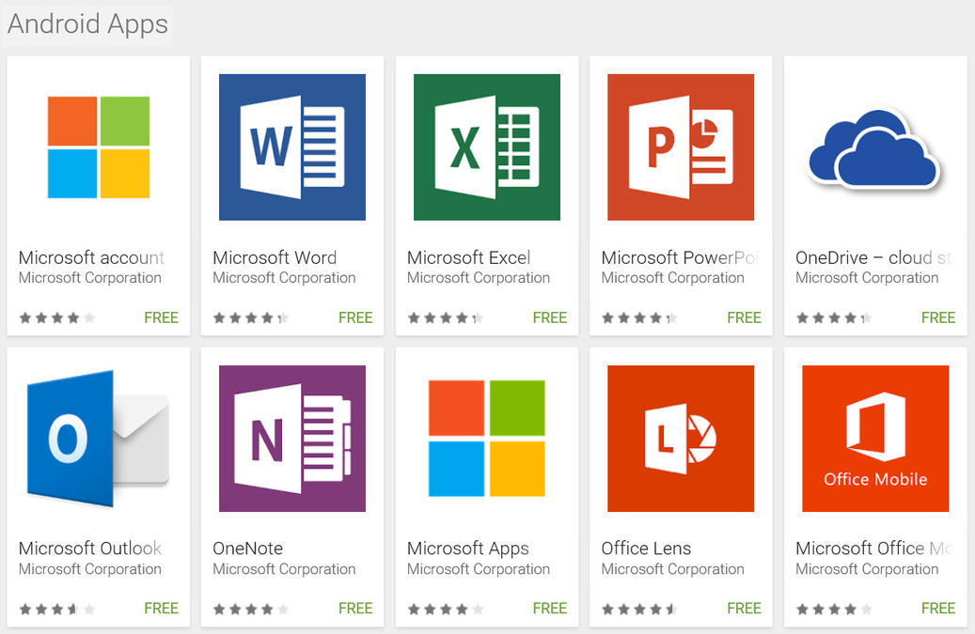

**Customized application software**

Customized software is that software which is made for particular client. Others cannot use that software until and unless the owner makes changes in it. For example Hotel billing system and shopping markets the software used in one shop may not be useful for another shop.

Customized business software can be used by any organization some popular customized business software are:

* **Payroll system**: The basic requirement of any small or large enterprise is computerized of the payroll system are basically used to create monthly salaries
* **School management system**: This software helps the school to manage all the process like fees, students’ data and teacher’s data etc.
* **Financial accounting**: this software is used mostly and it is the popular business application software.it is used to manage all the financial accounts.
* **Billing system and many more**

# 2.3) evaluate the use of web applications and mobile application to enhance user experience

Web application

Web application is type of application program which is stored on the remote servers which is distributed through internet through browser interface not all the websites includes web apps. According to web.storm.com any website that accomplishes some characteristics for the end user is said to be a web app. Web application are designed in a way that it can be used by anyone. The most commonly used web applications are e commerce shops, emails, Facebook and online scientific calculators. There are some web applications that can be accessed by précises browser; however most of the web applications are reachable no matter what the browser is.

As we all know web application can accessed online through internet there is no need of installing or downloading the web application. With the use of Google, Firefox or safari the user can get access to the web application

Working of the web application

For running the web application there should be a web server, application server.it manages the request that comes from the clients while application serves complete the requested task. Web apps are written in java, HTML or in CSS (CASCADING STYLE SHEET.). python, Ruby and java are the most commonly used for server side programing

There are many benefits of the web applications some of them are:

* It does not need to installed or downloaded in to your system
* The user can access web apps through mobile laptops or desktops.
* Same version of the application can be accessed by multiple users.

There two types of web applications

* Static web applications
* Dynamic web application

Static web applications

Static apps are known by its inflexibility by its simplicity of development from the other types of web the initial code must be modifying if you want something to be improved. The unavailability of database helps to offer safety to the page in the compassion with dynamic. Example 70%of word press sites are in danger, because they are getting hacked

Dynamic wed applications

It integrates the other types of web application in this way many different web languages can be used in developing web application but it will be very hard to code. But it has many advantages such as updating. The database allows us to read, update, create and delete data and information. It is divided into following types

Online stores: More than 20% of sales market increases every year. If anyone is scheduling to import there stores online they should have more focus on Ecommerce which not only includes e shopping it also has booking systems. It permits you to go through recommended items.

Portal web: it allows the user to go through various categories through home page. The user can use portal web to publish content create profile, email and financial transaction.

Animated web applications: These web apps uses flash technologies. It signifies the content with different visual animated effects. These types of web pages would not be a good for start up growing businesses.

**Mobile application**

Applications which are designed to run on the mobile phones are called mobile applications the use of mobile apps was promoted by Apple Company. Integrated software systems which are generally found in PCs mobile application have replaced them. Instead each app provides limited functionalities such as a calculator, games etc. in early mobile phones multi-tasking was not possible because of limited hardware resources. Mobile apps are developed precisely for the use on wireless computing devices such mobile phones tablets etc. Mobile apps are designed with limitations demands and of the devices

Theses mobile apps are categorized Mobile apps are sometimes characterized according to whether they are web-based or native apps which are created specifically for that platform A third kind, hybrid app which is the combination of web apps and native apps. As the technologies developing, probable the mobile application development efforts will focus on the creation of browser-based web applications

**Types of mobile application**

* Native apps
* Mobile web apps
* Hybrid apps
* PROGRESSIVE APPS

Native apps

These types of apps are built for specific type of operating system they are known as native app because they are built in to particular device. These types of Apps cannot be used by other operating systems. In other words we can say that iPhone apps cannot be used in android. The languages used in these apps uses development tools which supports only their own platform. Example: C language is used in IPhone apps and java is used in Android apps. These types of apps are really fast, they are easily available on Google apps. The main disadvantage of these apps is there are expansive to develop, maintenance is really hard and they are made for only one operating system.

Examples:

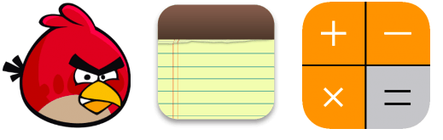

These types of apps use specific language java for android, Object C for IOS and c# for windows

Hybrid apps: they are the combination of native apps and mobile web apps. Same like native apps they are found in Google app stores and same like web apps they RELY HTML. They are easy to build compared to native apps they are much cheaper and faster to upgrade. The main disadvantages of these apps are they are less interactive apps slower than native apps and expensive then web apps.



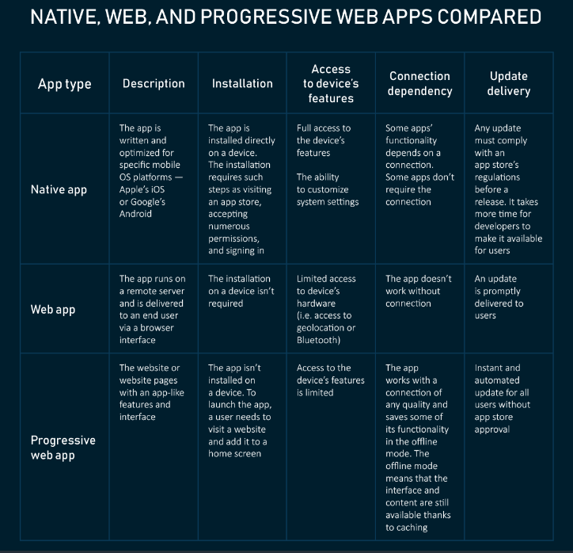

# References

# Bibliography

Ayusharma0698, n.d. *System Software*. [Online] Available at: <https://www.geeksforgeeks.org/system-software/> [Accessed 14 October 2019].

Beal, V., 2019. *RAM - random access memory*. [Online] Available at: <https://www.webopedia.com/TERM/R/RAM.html> [Accessed 23 October 2019].

Billboard, S., 2017. *Compilers and Interpreters*. [Online] Available at: <https://hackernoon.com/compilers-and-interpreters-3e354a2e41cf> [Accessed 14 October 2019].

chortle, n.d. *Components of a Computer System*. [Online] Available at: <https://chortle.ccsu.edu/java5/notes/chap01/ch01_3.html> [Accessed 13 October 2019].

computerhope, 2019. *Utility*. [Online] Available at: <https://www.computerhope.com/jargon/u/utility.htm> [Accessed 15 October 2019].

enotes, 2019. *What are the four basic functions of a computer system?* [Online] Available at: <https://www.enotes.com/homework-help/4-basic-functions-computer-system-500521> [Accessed 18 October 2019].

exposit, 2018. *What are the types of web applications?* [Online] Available at: <https://blog.exposit.com/what-are-types-web-applications/> [Accessed 20 November 2019].

hope, c., 2018. *What is the difference between an input and output device?* [Online] Available at: <https://www.computerhope.com/issues/ch001355.htm> [Accessed 3 November 2019].

Hope, C., 2019. *PS/2*. [Online] Available at: <https://www.computerhope.com/jargon/p/ps2.htm> [Accessed 25 October 2019].

Klosowski, T., 2019. *The Best Trackballs*. [Online] Available at: <https://thewirecutter.com/reviews/best-trackballs/> [Accessed 10 November 2019].

Rouse, M., 2011. *Web application (Web app)*. [Online] Available at: <https://searchsoftwarequality.techtarget.com/definition/Web-application-Web-app> [Accessed 20 November 2019].

Rouse, M., 2016. *register (processor register, CPU register)*. [Online] Available at: <https://whatis.techtarget.com/definition/register> [Accessed 19 October 2019].

Techdifferences, 2018. *Difference between SIMM and DIMM*. [Online] Available at: <https://techdifferences.com/difference-between-simm-and-dimm.html> [Accessed 23 October 2019].

techopedia, 2019. *Peripheral Device*. [Online] Available at: <https://www.techopedia.com/definition/2252/peripheral-device> [Accessed 4 November 2019].

THAKUR, D., n.d. *What is Secondary Memory? - Definition*. [Online] Available at: <http://ecomputernotes.com/fundamental/input-output-and-memory/secondary-memory> [Accessed 23 October 2019].

William, a., 2019. *Operating systems: internals and design principles*. Eighth edition. ed. Boston: Pearson, [2015].

Zandbergen, P., 2019. *What Are Peripheral Devices of a Computer? - Definition, Examples & Types Video*. [Online] Available at: <https://study.com/academy/lesson/what-are-peripheral-devices-of-a-computer-definition-examples-types.html> [Accessed 4 November 2019].

Destefano, G.F., International Business Machines Corp, 2000. *Computer system and method of manipulating multiple graphical user interface components on a computer display with a proximity pointer*. U.S. Patent 6,075,531.